University Collage Of Engineering And Technology,Bikaner

Major Project

On

EMPLOYEE MANAGEMENT SYSTEM

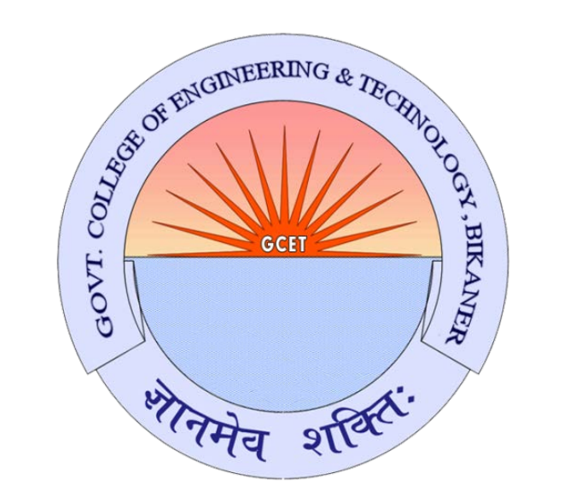

Name of Teacher: - Student Name:-

Mr. Devender Dailha Siddarth Ladnia

ROLL NO:-

16ECTCS074

# DECLARATION

I **Siddarth Ladnia** student of B.Tetch (IT) hereby declare that the Project titled **“Employee Management System”** which is submitted by me to **Devender Dailha**, Govt Collage Of Engineering And Technology, Bikaner, in partial fulfillment of requirement for the award of the degree of DEGREE NAME.STREAM, has not been previously formed the basis for the award of any degree, diploma or other similar title or recognition. The Author attests that permission has been obtained for the use of any copy righted material appearing in the Dissertation

Project report other than brief excerpts requiring only proper acknowledgement in scholarly writing and all such use is acknowledged.

## Place- Bikaner Student Name- Siddarth Ladnia

Date- 18/09/2020 Enrollment No- 16ECTCS074

2

COLLEGE LOGO

# GUIDE CERTFICATE

I hereby certify that the Seminar Report by **Siddarth**, student of **CSE. 6th Semester 16ECTCS074** with title **“Employee Management System”** which is submitted to Govt Collage Of Engineering And Technology, Bikaner in partial fulfillment of requirement for the award of the degree of BTech. IT is an original contribution with existing knowledge and faithful record of work carried out by him/her under my guidance and supervision and to the best of my knowledge this work has not been submitted in part or full for any Degree or Diploma to this University or elsewhere.

Place –Bikaner, Rajasthan PROFESSOR NAME

Date: 18/09/2020 Assistant Professor

COLLEGE NAME

# ACKNOWLEDGEMENT

It is high privilege for me to express my deep sense of gratitude to those entire faculty Members who helped me in the completion of the project, specially my internal guide **Mr. Devender Dailha** who was always there at hour of need. My special thanks to all other faculty members, Batchmate & Seniors of Govt Collage Of Engineering And Technology, Bikaner for helping me in the completion of project work and its report submission.

STUDENT Siddarth

ROLL NO

16ECTCS074

**TABLE OF CONTENTS**

|  |  |  |
| --- | --- | --- |
| **S. No.** | **Topic** | **Page No.** |
| 1 | Declaration | 2 |
| 2 | Certificate | 3 |
| 3 | Acknowledgement | 4 |
| 4 | Abstract | 6 |
| 5 | Chapter-1: Introduction | 6 |
| 6 | Chapter-2: Objective | 6 |
| 7 | Chapter-3: Methodology | 7 |
| 8 | Chapter-4: Feasibility Study | 8 |
| 9 | Chapter-5: Implementation and Results | 9 |
| 10 | Chapter-6: Testing | 12 |
| 11 | Chapter-7: Conclusion | 13 |
| 12 | Chapter-8: Future Scope | 13 |
| 13 | Chapter-9: References | 14 |

**TABLE OF FIGURES**

|  |  |  |
| --- | --- | --- |
| **Figure No.** | **Caption of the Figure** | **Page No.** |
| 1 | Login frame | 9 |
| 2 | Main Dashboard | 9 |
| 3 | Add employee | 10 |
| 4 | Remove employee | 10 |
| 5 | View and Update employee | 11 |

# Abstract

*Human resource difficulties face all businesses, large and small. Because every organization has different staff management needs, we create custom employee management solutions that are tailored to your needs. This is intended to aid strategic planning and guarantee that your firm has the appropriate degree of human resources to meet your long-term objectives. This approach will help you to better manage your resources in the long run.*

# Introduction

Everything has been digitised in our age of ever-increasing technology. The human workforce has grown as a result of the abundance of job options. As a result, a system that can handle the data of such a vast number of people in a company is required. Because of its user-friendly design, this project makes the process of keeping records easier. The "EMPLOYEE MANAGEMENT SYSTEM" was created to address the issues that plagued the previous manual system. This programme is designed to eliminate, and in some cases, decrease, the problems that the current system has.

To eliminate data entry mistakes, the software is kept as simple as possible. When inputting incorrect data, it also displays an error notice. The user doesn’t require any formal expertise to operate this system. The admin will be able to add new employees to this project. Employee data may also be seen and printed by the administrator. Admins can also remove an employee and change their details.

# Objective

The objective of this work is to give a complete approach to personnel information management. This will be accomplished by developing and deploying an HR management system that will result in a significant shift in the way employee data is managed.

This system's objectives include the following:

1. Design of an HR management system to meet needs such as adding and deleting employees, viewing and printing employee data, and updating employee information.
2. Employee data is stored in a well-designed database.
3. An easy-to-use interface that will let user interact with the system.

# Methodology

The methodology to complete this project is as follows:

1. I explored net beans, concepts of swings and applets.
2. For further and a deeper understanding, I even referred to some articles, books, journals, websites and news articles.

Below are the important concepts on which the work has been done and with the support of these I was able to work on my project.

**NET BEANS-** NetBeans is a Java-based integrated development environment (IDE). NetBeans enables the creation of applications using a set of modular software components known as modules. NetBeans is compatible with Windows, Mac OS X, Linux, and Solaris. It also allows other programming languages to be extended. In addition to Java programming, Third-party developers can expand NetBeans-based applications, including the NetBeans IDE.

**JAVA-** High-level, Object-Oriented programming language which help programmers to run their applications efficiently. JAVA is the programming language which comes into our minds when we talk about android application. By using JAVA as a programming language, programmer can develop any type of android application easily. JAVA also provides many libraries which also helps in making efficient android application. Swing is a Java GUI widget toolkit. It's part of Oracle's Java Foundation Classes (JFC), which provides an API for creating graphical-user- interfaces for Java programmes.

**SWING-** Swing is a Java GUI widget toolkit. It's part of Oracle's Java Foundation Classes (JFC), which provides an API for creating-graphical-user-interfaces for Java programmes. Swing was created to give a more advanced collection of graphical user interface components than the previous Abstract Window Toolkit (AWT). Swing offers a pluggable look and feel that allows applications to have alook &feel that is unconnected to the underlying platform, as well as a look & feel that emulates the look & feel of numerous platforms.

**SQL-** SQL (Structured Query Language) is a computer language that is used to manage data in a relational database management system (RDBMS) or for stream processing in a relational data stream management system (RDSMS). It's especially beneficial for dealing with structured data, or data that has relationships between entities and variables.

# Feasibility Study

In order to do a feasibility study, we must consider the following:

1. **Technical Feasibility**

The availability of hardware & Software necessary for the creation of the system, as-well- as the compatibility and maturity of the technology planned to be used, and the availability of the requisite technical staff to create the system, are all factors to consider.

1. **Operational Feasibility**

Problems that may develop during operations are the focus of operation feasibility. There are two parts to this problem to consider:

* + What are the chances that the solution provided will not be used or will not work?
  + What is the inclination of-the management and end users towards the solution?

1. **Economic Feasibility**

The concept of economic feasibility is determining whether or not the potential benefit of fixing difficulties is worth while. Because member needs &alternative solutions haven’t been specified at this point, it is difficult to estimate the cost at this level.

# IMPLEMENTATION AND RESULT

Following are the screens of the Employee Management System where you can see all the features of this system in use and you can also see the GUI of the system:

1. 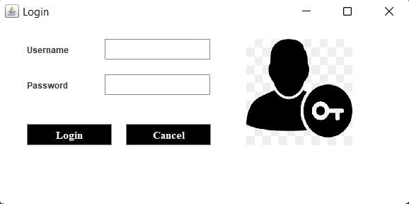**Login frame** – This is the login frame of this system where user have to enter the required credentials to have access for the main dashboard.

Fig. 1

1. **Main Dashboard** – After login in, user is directed to the main dashboard of this system where user can perform various operations like adding an employee, deleting an employee

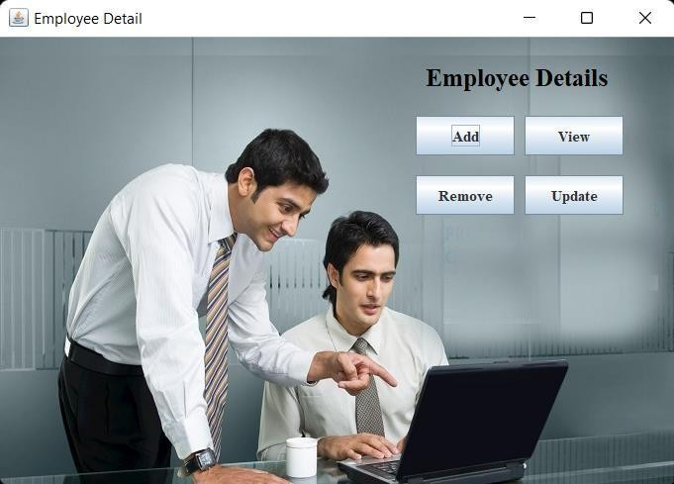

Fig. 2

1. **Add employee** – Here user have to enter all the required credentials to add a new employee to the system.

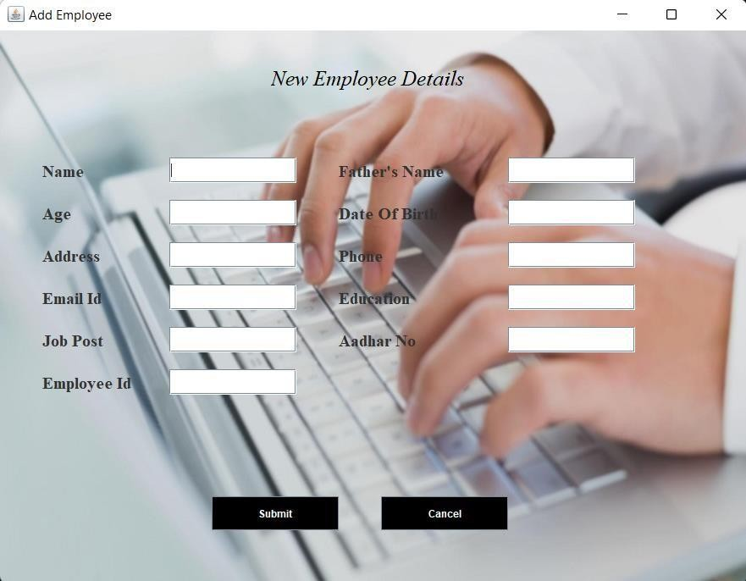

Fig. 3

1. **Remove employee** – User has to enter the employee id in order to delete his information from the system.

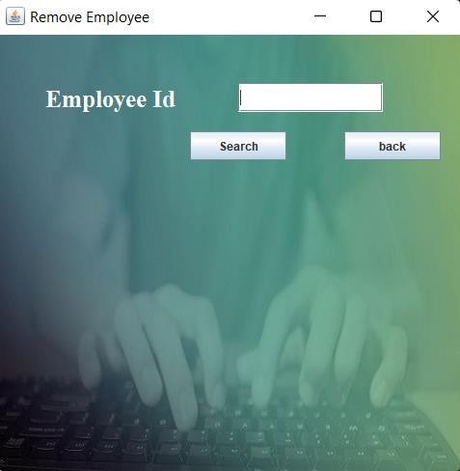

Fig. 4

1. **View and update employee** – In order to view and update employee information, the user have to enter employee ID.

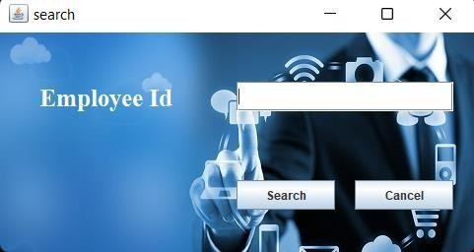

Fig. 5

# Testing

|  |  |  |  |  |  |
| --- | --- | --- | --- | --- | --- |
| **Test ID** | **Test- Purpose** | **Test-Condition** | **Expected-Output** | **Output** | **Remark** |
| TC1 | Check Username & Password | If user details are not correct, display error message | Grant access to main dashboard. | Access granted to main dashboard | Test successful |
| TC2 | To add new user to the system | If user already exists, error message should be displayed. | New user should be added. | New user added successfully | Test Successful |
| TC3 | To view existing employee information | If employee exists, then information should be displayed, else error message should be displayed. | Employee information should be displayed. | Employee information displayed. | Test Successful |
| TC4 | To remove an employee | If employee exists, then employee should be removed else error message should be displayed. | Employee should be removed. | Employee removed successfully. | Test Successful |
| TC5 | Update employee information | If employee exists, then information should be updated. | Employee information should be updated. | Employee information updated successfully | Test Successful |

1. **Conclusion**

The goal of the initiative is to digitise personnel databases in businesses and provide administrators access to computers. Employees and administrators use software as an information system. The user can store his or her database safe and secure for an indefinite amount of time here. Adding, deleting, accessing, and changing employee information is simple and easy using the Employee Management System.

# Future Scope

The GUI and the features added to this system are the basic ones. In future, there will be a better Graphical User Interface and there will be more features added to this system. If Graphical User Interface is improved then this system will be more user friendly and more features added will make this system a lot better and HR will be able to perform more operations.

# References

* 1. Renae Broderick, John W. Boudreau, “Human resource management, information technology, and the competitive edge”, Academy of Management Executive, 1992 Vol. 6 No. 2
  2. Julie Bulmash, “Human Resource Management and Technology”, Chapter 3.
  3. Ian Sommerville, “Software Engineering”, 9th Edition, Addison-Wesley, 2011.
  4. Avison, D. and Fitzgerald, G. (2003).Information systems Development Methodologies, Techniques and Tools.3rd Edition. McGraw-Hill Education Limited Bershire
  5. Juan Manuel Munoz Palacio, Information systems development methodologies for Data-driven Decision Support Systems, 2010.
  6. Deitel, PJ & Deitel, HM, 2008, Internet & World Wide Web How To Program,Dorling Kindersley, India.

**COLLEGE NAME**

**WEEKLY PROGRESS REPORT (WPR)**

### For the week commencing: 03/01/2022

WPR - 1

Enrolment Number : ROLL NO

Program : DEGREE

Student Name : NAME

Faculty Guide’s Name : NAME Co- Guide’s Name :

Project Title : GUI based application for HR solution

### TARGETS SET FOR THE WEEK

* Finalize the project topic

### PROGRESS FOR THE WEEK

* Discussed project topic with my NTCC guide and finalized it

### FUTURE WORK PLANS

* Project planning, Internet downloads

COLLEGE NAME

### WEEKLY PROGRESS REPORT (WPR)

**For the week commencing: 04/01/2022**

WPR - 2

Enrolment Number : ROLL NO

Program : DEGREE

Student Name : NAME

Faculty Guide’s Name : NAME Co- Guide’s Name :

Project Title : GUI based application for HR soution

TARGETS SET FOR THE WEEK

* Project planning
* Internet downloads
* Overview

PROGRESS FOR THE WEEK

* Project planned
* Internet downloaded
* Overview

FUTURE WORK PLANS

* GUI designing
* Coding

Project Title : GUI based application for HR soution COLLEGE NAME

### WEEKLY PROGRESS REPORT (WPR)

**For the week commencing: 04/01/2022**

WPR - 3

Enrolment Number : ROLL NO

Program : DEGREE

Student Name : NAME

Faculty Guide’s Name : NAME Co- Guide’s Name :

Project Title : GUI based application for HR soution

TARGETS SET FOR THE WEEK

* GUI designing
* Coding

PROGRESS FOR THE WEEK

* Designed GUI
* Started working on code

### FUTURE WORK PLANS

* Deciding the features to be added
* Finalizing decided features

PROGRESS FOR THE WEEK

COLLEGE NAME

### WEEKLY PROGRESS REPORT (WPR)

**For the week commencing: 24/01/2022**

*WPR - 4*

*Enrolment Number : ROLL NO*

*Program : DEGREE*

*Student Name : NAME Faculty Guide’s Name: NAME*

*Project Title : GUI based application for HR soution*

TARGETS SET FOR THE WEEK

* Deciding the features to be added
* Finalizing decided features

PROGRESS FOR THE WEEK

* Features that will be added to the project are : Login page, main dashboard, add employee, viewemployee & print data, removing an employee, updating information.

COLLEGE NAME

### WEEKLY PROGRESS REPORT (WPR)

**For the week commencing: 31/01/2022**

WPR - 5

Enrolment Number : 16ECTCS074

Student Name : Siddarth

Faculty Guide’s Name : Mr.Devender

Co- Guide’s Name :

Project Title : GUI based application for HR solution

TARGETS SET FOR THE WEEK

* Start working on creating connection class

PROGRESS FOR THE WEEK

* Done with the development of connection class that will be used to connect to the database tostore employee data

FUTURE WORK PLANS

* Start working on creation of front page of the project

### COLLEGE NAME

**Major Project**

Daily Diary

### Daily Diary: 1 Daily Diary Remaining: 14

**Student Name:** Siddarth Ladnia

**Enrollment Number:** 16ECTCS074

**Project Title:** GUI based application for HR solution

Week’s Summary

|  |  |
| --- | --- |
| Days/Time |  |
|  |  |
| 3/01/2019 | Started searching the project. |
|  |  |
| 4/01/2019 | Decided the project. |
|  |  |
| 5/01/2019 | Studied overview of the project. |
|  |  |
| 6/01/2019 | Discussed and finalized it with my guide. |
|  |  |
| 7/01/2019 | Analyzing the week’s progress and identifying the objectives of next week. |